Aligarh Civic
-In Column 7
eclipse not caught in the whole column of the CSV except 4th row
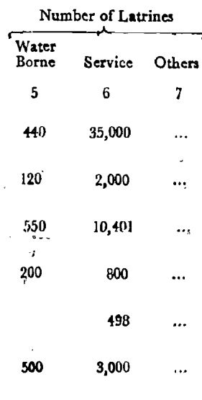
In Column 9 and 10
- Column mixing: TW/OHT and 400,000 Galls. were merged into one field instead of being assigned to Source and Capacity separately.
- OCR truncation: TW/OHT became T due to token/character loss.
- Row loss: HP ... and HP/W ... disappeared because ... was treated as empty/noise.
- Structural failure: The pipeline is relying on OCR text order rather than visual X/Y coordinates and actual row/column boundaries. Main error: This is primarily a table-structure/column-boundary error, not just an OCR spelling error
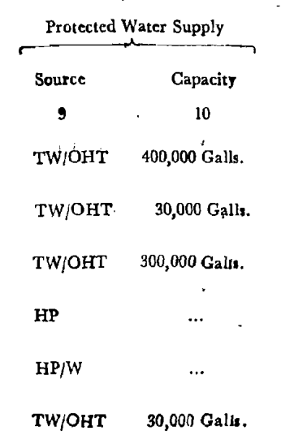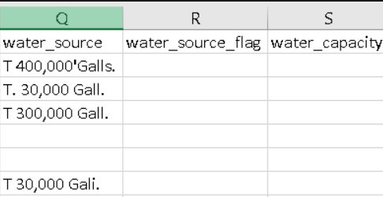
-Aligarh mededu
Not displaying in the OCR csv
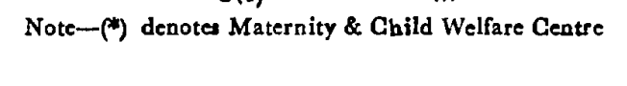
-In Column 6 CSV, this text:
Medical Colleges Field | Expected Value 1 | 02 | 03 | 0
means our validation system is saying: “For the Medical Colleges field, I expected one of these values: 1, 2, 3, or 0.”
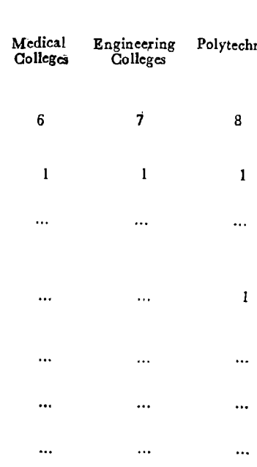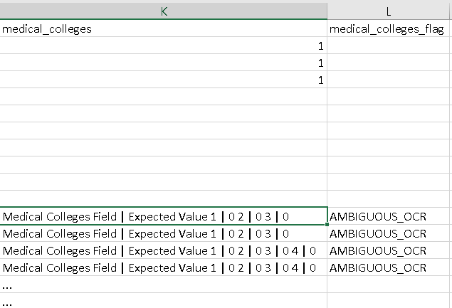

Aligarh tehsil
-values are shifting/missing between columns, even though the OCR itself can clearly recognize the numbers.
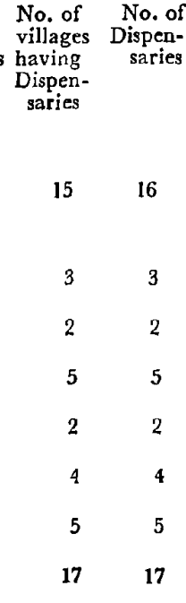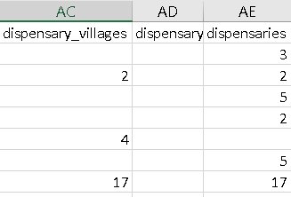
- ... → numbers: Printed ... is being incorrectly interpreted as 4 or 44.
- Column misalignment: Values are not consistently assigned to the correct column.
- Valid ... treated as ambiguous/missing: The dotted values should be preserved as actual table values.
- False OCR confidence: 44 is particularly problematic because the source clearly shows ..., not 44.
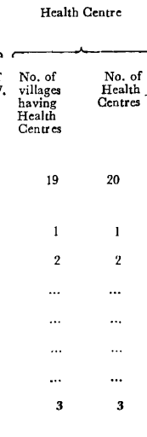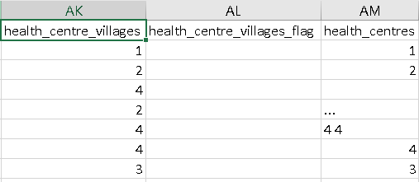
This is mainly a dotted-value misrecognition + column assignment error
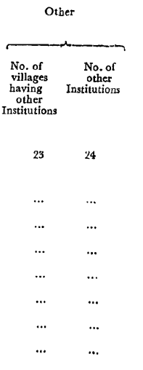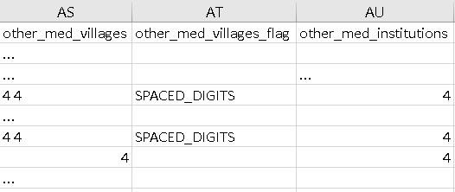
Allahahabad Civic
- Row-boundary error: The OCR has incorrectly split/merged the visual rows. For example, Allahabad, Allahabad Cantt., and Subedarganj Bharatganj Rly. Colony data are shifted across rows.
- Duplicate text within cells: Text such as “Allahabad See CITY URBAN …”, “PT/OSD PT/OSD PT/OSD”, and “B B” is repeated.
- Column-shift error: Values from adjacent columns have been placed in the wrong fields, e.g. 237 389, 7 320, etc.
- Page-continuation error: The second-page values (Water Source, Capacity, Fire Service, Electrification) are not correctly aligned with the corresponding rows from page 1.
- OCR spacing/format error: Agrlomeration, AGGLO City MERATION, 15,00Galls., etc. show incorrect word/number segmentation.
- Missing values incorrectly represented: Several ... values from the source are not consistently preserved in the correct columns.
- Town-name contamination: Town names contain text belonging to other columns/rows, e.g. “(iii) Subedarganj Bharatganj Rly. Colony Rly. Colony.”
- Incorrect row classification: Allahabad Cantt. and Subedarganj Bharatganj Rly. Colony are marked as COMPONENT, but the extraction structure does not cleanly represent their actual visual rows.
- Cross-reference rows are incorrectly captured: See Allahabad City Urban Agglomeration has been merged with unrelated values such as 442 and HC.
- Overall: The major problem is structural column/row alignment, not just individual OCR character errors.
Allahahbad mededu
- Major row-boundary error: Row (ii) Allahabad Cantt. is merged with (iii) Subedarganj Rly. Colony in the CSV.
- Name contamination: CSV row (ii) contains “Rly. Subedarganj Colony Allahabad Cantt.”, combining text from two separate source rows.
- Cross-reference rows are misplaced: See Allahabad City Urban Agglomeration is incorrectly attached to the wrong row instead of being retained as the continuation/reference row.
- Column-shift error: Medical values such as H (17), D (2), TBC (2), NH (1), FC (4), *O (1), 1,436 are collapsed into a single field rather than being distributed across the appropriate medical-facility columns.
- Repeated/concatenated values: H D TBC NH FC (17) (2) (2) (1) (4) loses the original row/column structure.
- Cell concatenation error:
AS A S S AGGLO (3) (2) (1) (1) is being put into one degree_colleges cell, whereas the source has separate entries such as A(3), AS(2), S(1).
- Numeric OCR/structure error: Values such as 100 and 24 are present but are not reliably assigned to their correct medical columns/rows.
- Missing row content: Mauaima is present as a row, but its source ... values are not cleanly represented; unrelated text such as “important commodity infra.” has been inserted into the row.
- Severe contamination in Phulpur row: The row contains unrelated text such as “1st”, “2nd”, “3rd”, “No. of Banks”, “Agricultural Credit Societies”, etc., which belongs to a different statement/table.
- Severe contamination in Sirsra row: The row contains large blocks of unrelated bank/society numbering such as 33:49:65:81:97..., showing that text from another table has been absorbed.
- Page/table contamination: Rows after the town data contain text from “STATEMENT 1 / INDUSTRY AND …”, which is not part of the medical/educational table.
- Second-page structural failure: The Cultural Facilities table (columns 10–17) has not been correctly captured as a continuation of the town rows; instead, unrelated headers/text are mixed into the existing records.
- Incorrect classification: The CSV marks some ordinary town rows with erroneous structural labels such as BANKING, apparently caused by contamination from a later table.
Allahabad Tehsil
- Page 1 educational section is mostly correct, but there are some OCR/name errors:
  - Sirahut → should be Sirathu.
  - Hindia → should be Handia.
- Page 1 Medical/Power/Drinking Water data are severely misaligned after the educational columns.
- Many values are placed in the wrong columns, e.g. 265, 3, 502, 22 29, etc.
- OCR hallucination/text contamination: long descriptions such as tahsil_abstract_1971; panel: tahsil_power_water... have been inserted into data cells.
- Non-table text has entered cells, e.g. This image does not contain any data..., markdown-like text, and Hindi/Chinese characters.
- Repeated values are concatenated incorrectly, e.g. 1 1 1 1..., 2 2, 3 3, instead of being assigned to their individual columns.
- Decimal/character corruption: examples include 0.00, 3U0, U, +, 一, etc. where the source contains —, numbers, or blanks.
- Drinking-water columns are badly shifted: values such as 265, 308, 502, 123, 193 are not consistently assigned to the correct water-source columns.
- Communications columns are badly shifted/contaminated: values such as 104, 194, H, 91, etc. are placed incorrectly.
- Page 2 medical and communications rows are not correctly separated/aligned with the 8 Tahsil rows.
- District Total row is incomplete/misaligned for the later sections; only some values are correctly retained.
- Extra junk rows (rows 9–13) have been created from table headers and OCR output instead of being excluded from the actual data.
- Overall main error: the educational table has relatively good row structure, but the continuation sections (Power Supply, Drinking Water, Medical, Communications) suffer from major column/row alignment and cross-content contamination.
Almora Civic
- Major row-merging error: 4 Bageshwar Ranikhet Cantt. is combined into one CSV row. These are two separate rows.
- Almora Urban aggregate row has wrong continuation data: it should have 438,000 Galls., 1,861, 11, 687, 784, but the CSV contains 120,000 Galls., 1,840, 10, 680, 784.
- (i) Almora row has wrong page-2 data: it should have 120,000 Galls., 1,840, 10, 680, 734, but CSV has 318,000 Galls., 21, 1, 7, 50.
- (ii) Almora Cantt. row has wrong page-2 data: it should have 318,000 Galls., 21, 1, 7, 50, but CSV has 115, 4, 150, 62.
- Bageshwar data is merged/misaligned: its page-2 values R / ... / ... / 115 / 4 / 150 / 62 are mixed with Ranikhet.
- Ranikhet Cantt. row is missing as a separate logical row: its correct continuation is SR/R, 73,000 Galls., Yes, 292, 5, 336, 234, ....
- Latrine columns are also merged for Bageshwar/Ranikhet: 10/218/6 and 140/58/520 are combined into the same CSV record.
- Road-length values are merged: PR (5) KR (3) and PR (11) KR (3) belong to separate towns but appear together.
- OCR typo: 73,000 Sails. should be 73,000 Galls.
- Overall: the biggest issue is row correspondence across the two pages—the CSV is not maintaining one visual/logical town row across the continuation tables.
Almora Mededu
- Ranikhet Cantt. contamination: a huge repeated sequence of 1 1 1 1... has been inserted into the CSV and flagged as SPACED_DIGITS; this is not source data.
- Cultural Facilities row structure is lost: the values for columns 10–17 are not reliably associated with the corresponding towns.
Problem with:
primary_schools Column
15 15 15 15 15 15 15 15 15 15 15 15 15 15 15 15 15 15 15 15 15 15 15 15 15 15 15 15 15 15 15 15 15 15 15 15 15 15 15 15 15 15 15 15 15 15 15 15 15 15 15 15 15 15 15 15 15 15 15 15 15 15 15 15 15 15 15 15 15 15 15 15 15 15 15 15 15 15 15 15 15 15 15 15 15 15 15 15 15 15 15 15 15 15 15 15 15 15 15 15 15 15 15
15 15 15 15 15 15 15 15 15 15 15 15 15 15 15 15 15 15 15 15 15 15 15 15 15 15 15 15 15 15 15 15 15 15 15 15 15 15 15 15 15 15 15 15 15 15 15 15 15 15 15 15 15 15 15 15 15 15 15 15 15 15 15 15 15 15 15 15 15 15 15 15 15 15 15 15 15 15 15 15 15 15 15 15 15 15 15 15 15 15 15 15 15 15 15 15 15 15 15 15 15 15 15
15 15 15 15 15 15 15 15 15 15 15 15 15 15 15 15 15 15 15 15 15 15 15 15 15 15 15 15 15 15 15 15 15 15 15 15 15 15 15 15 15 15 15 15 15 15 15 15 15 15 15 15 15 15 15 15 15 15 15 15 15 15 15 15 15 15 15 15 15 15 15 15 15 15 15 15 15 15 15 15 15 15 15 15 15 15 15 15 15 15 15 15 15 15 15 15 15 15 15 15 15 15 15
15 15 15 15 15 15 15 15 15 15 15 15 15 15 15 15 15 15 15 15 15 15 15 15 15 15 15 15 15 15 15 15 15 15 15 15 15 15 15 15 15 15 15 15 15 15 15 15 15 15 15 15 15 15 15 15 15 15 15 15 15 15 15 15 15 15 15 15 15 15 15 15 15 15 15 15 15 15 15 15 15 15 15 15 15 15 15 15 15 15 15 15 15 15 15 15 15 15 15 15 15 15 15
..
..
..
..
stadia
..
..
..
..
1 1 1 1 1 1 1 1 1 1 1 1 1 1 1 1 1 1 1 1 1 1 1 1 1 1 1 1 1 1 1 1 1 1 1 1 1 1 1 1 1 1 1 1 1 1 1 1 1 1 1 1 1 1 1 1 1 1 1 1 1 1 1 1 1 1 1 1 1 1 1 1 1 1 1 1 1 1 1 1 1 1 1 1 1 1 1 1 1 1 1 1 1 1 1 1 1 1 1 1 1 1 1 1 1 1 1 1 1 1 1 1
1 1 1 1 1 1 1 1 1 1 1 1 1 1 1 1 1 1 1 1 1 1 1 1 1 1 1 1 1 1 1 1 1 1 1 1 1 1 1 1 1 1 1 1 1 1 1 1 1 1 1 1 1 1 1 1 1 1 1 1 1 1 1 1 1 1 1 1 1 1 1 1 1 1 1 1 1 1 1 1 1 1 1 1 1 1 1 1 1 1 1 1 1 1 1 1 1 1 1 1 1 1 1 1 1 1 1 1 1 1 1 1
1 1 1 1 1 1 1 1 1 1 1 1 1 1 1 1 1 1 1 1 1 1 1 1 1 1 1 1 1 1 1 1 1 1 1 1 1 1 1 1 1 1 1 1 1 1 1 1 1 1 1 1 1 1 1 1 1 1 1 1 1 1 1 1 1 1 1 1 1 1 1 1 1 1 1 1 1 1 1 1 1 1 1 1 1 1 1 1 1 1 1 1 1 1 1 1 1 1 1 1 1 1 1 1 1 1 1 1 1 1 1 1
1 1 1 1 1 1 1 1 1 1 1 1 1 1 1 1 1 1 1 1 1 1 1 1 1 1 1 1 1 1 1 1 1 1 1 1 1 1 1 1 1 1 1 1 1 1 1 1 1 1 1 1 1 1 1 1 1 1 1 1 1 1 1 1 1 1 1 1 1 1 1 1 1 1 1 1 1 1 1 1 1 1 1 1 1 1 1 1 1 1 1 1 1 1 1 1 1 1 1 1 1 1 1 1 1 1 1 1 1 1 1 1

libraries
PL RR PL RR (2) (2) (2) (2)
PL RR PL RR (2) (2) (2) (2)
PL RR PL RR (2) (2) (2) (2)
PL RR PL RR (2) (2) (2) (2)
.. ..
.. ..
.. ..
.. ..
PL (1)
PL (1)
1
1
1
1

Almora Tehsil
- Tahsil name OCR errors: Rankihet should be Ranikhet.
- Major column contamination in Medical section: values/flags such as SPACED_DIGITS and AMBIGUOUS_OCR have entered actual data columns.
- Medical values are misaligned/duplicated: e.g. Almora's medical fields contain 14, 14, 12, 12, etc. in places where the source has separate paired columns.
- Severe column corruption in District Total: the column-number sequences (35 45 55..., 36 46 56...) have been inserted into data fields. These are header/column-number OCR artifacts, not data.
- District Total row contamination: (Rural) has been separated into its own row, although it belongs with District Total (Rural).
- Flag columns are polluted: SPACED_DIGITS, TRAILING_MARK_REMOVED, and AMBIGUOUS_OCR appear inside the extracted table data rather than being clean validation metadata.
- Drinking Water section: the source has columns 27–38; the CSV shows some correct values but also missing/shifted fields and OCR artifacts.
- Communications section: values such as 231, 1,216, 33, 16, 129 etc. are largely captured, but some later columns contain .../OCR artifacts instead of clean missing values.
- Major metadata contamination: text such as PSUP (R) 32 Janganna/181—1974.—745 Books. has entered the (Rural) row even though it is not table data.
- Overall error: this sample is primarily a column-level OCR contamination/alignment problem, especially in the Medical and District Total sections, rather than a logical row-boundary problem.

Azamgarh Civic
- Major row-loss error: Source has 5 town rows (Azamgarh, Kopaganj, Maunath Bhanjan, Mubarakpur, Muhammabad), but CSV contains only 1 row (Azamgarh).
- Page-1 data for Azamgarh is mostly aligned correctly: PR (25), KR (4), PT/OSD, 801, 7,524, ..., B.
- Page-2 continuation is incorrectly attached to Azamgarh: CSV has HP, 125, 77, 257, 295, but these belong to a different source row, not Azamgarh.
- Water Supply mismatch: Azamgarh should have TW/OHT + 60,000 Galls., but CSV records HP + blank capacity.
- Electrification mismatch: Azamgarh should have Domestic 3,525; Industrial 180; Commercial N.A.; Road lighting 1,200. CSV instead has 125, 77, 257, 295.
- Missing page-2 continuation rows: The corresponding water/electrification records for Kopaganj, Maunath Bhanjan, Mubarakpur, and Muhammabad are absent.
- Cross-page row correspondence failure: The pipeline is not maintaining the same town → continuation row relationship between the two pages.
- Overall error: row extraction/truncation + continuation-table misalignment. The first-page town block is detected, but the second-page values are taken from the wrong visual row and the remaining towns are lost.

Most important new error azamgarh tehsil
Adjacent columns being merged into a single numeric cell — e.g. 702 + 1,006 → "702,1,006" and 7,280 + 5,176 → "7,280,5,176".
Looking across all the samples so far, the errors we have detected can be consolidated into these distinct error categories. I’m excluding duplicates of the same underlying problem.

Distinct OCR / digitisation errors detected so far
- Incorrect logical row boundary
  - Separate towns/entries are merged into one row.
  - Example: Bageshwar + Ranikhet Cantt. merged.
Missing rows / row loss
  - Entire town records disappear from the CSV.
  - Example: in one sample, only Azamgarh survived while the other four towns were missing.
- False/spurious rows
  - Headers, notes, or OCR junk are converted into actual data rows.
- Cross-page row correspondence error
  - Page 2 continuation values are attached to the wrong town from page 1.
  - This is particularly important in the Amenities 1969 continuation tables.
- Column shift / column misalignment
  - A value is extracted but placed under the wrong column.
  - This is one of the most frequent errors.
- Cross-section column mixing
  - Values from Medical, Educational, Power Supply, Drinking Water, Communications, Cultural Facilities, etc. get assigned to columns belonging to another section.
- Cross-table contamination
  - Text/data from a completely different table or statement enters the current table.
  - Example: banking/industry-related text appearing in a Medical/Educational table.
- Header contamination
  - Column numbers (13, 14, 15...) or header labels are extracted as actual data.
- Footer/note contamination
- Footnotes, page numbers, notes, or source references enter the CSV data.
- Example: PSUP—104 Census—1974—750 Books....
- Metadata/validation contamination
- Processing labels such as AMBIGUOUS_OCR, SPACED_DIGITS, TRAILING_MARK_REMOVED appear inside the actual data fields instead of remaining metadata/flags.
- Cell/value concatenation
- Two or more separate values become one CSV cell.
- Example: 702, 1,006 treated as a single value.
- Missing-value corruption
- Source ..., —, or blank values are converted inconsistently into blanks, OCR characters, or unrelated values.
- Character-level OCR error
- Individual characters/words are misread.
- Examples:
  - Almora → AI mora / Al mora
  - Ranikhet → Rankihet
  - Phulpur → Publpur
- Number recognition error
- Digits themselves are incorrectly recognized.
- Examples include malformed numbers, extra digits, dropped digits, or 1,006-type corruption.
- Punctuation/format corruption
- Commas, parentheses, decimal points, hyphens, etc. are altered.
- Example: 73,000 Galls. becoming 73,000 Sails.
- Repeated/garbled OCR text
- OCR produces strings of repeated digits/characters that have no corresponding source content.
- Example: long sequences like 1 1 1 1....
- Town-name contamination
- Text belonging to another row/column becomes part of the town name.
- Example: town names containing Rly. Colony, Allahabad Cantt. etc. from neighboring rows.
Also note one more point There are minor issues

- in Allahabad civic [ALLAHABAD CITY URBAN AGGLOMERATION] should Come under town name only, it is getting joineed under different column
- [ALLAHABAD CITY URBAN AGGLOMERATION in mededu under town name should come. And in the 5th column A (3) AS (2) S (1) is wriiten as AS A S S AGGLO (3) (2) (1) (1), and A (3) AS (2) S (1) is written as A AS AS S (3) (2) (2) (1) and also in the column libraries PL (20) RR (1) written as PL RD (20) /1. Correct if you see this issues in other csv as well. Similarly in almora civic we can see under town name written only “URBAN” but it should be “Almora Urban Agglomeration”
- After addressing this, start post processing for all 15 csvs

